Chapter 12, Problem 6.

Using Fig. 12.41, design a problem to help other students better understand balanced wye-wye connected circuits.
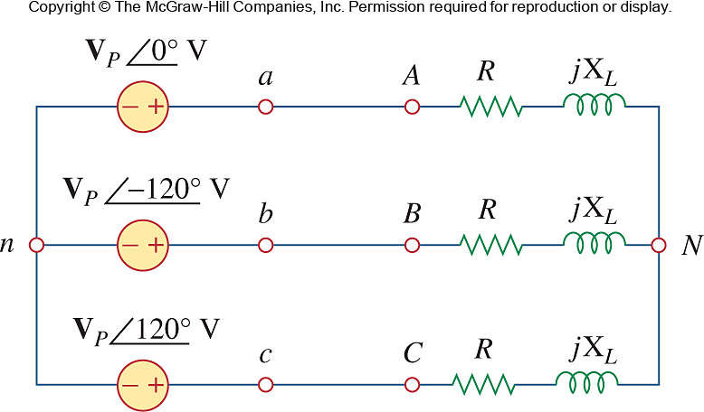

Figure 12.41
For Prob. 12.6.

